Zoomaster GUI user guide

**Introduction**

Zoomaster GUI is as its name suggest a GUI version of [Zoomaster](https://github.com/AY2021S1-CS2113T-W11-1/tp), a command line interface App produced for a university finals (team) project. Zoomaster helps you easily access lesson links necessary for your academics. You can assign time and day of the week for your lesson links. Additionally, you can add other necessary links required for your lessons.

The GUI allows you to easily add, edit, remove and launch your lesson links compared to the command line interface. This guide will walk you through how to use Zoomaster.

**Table of Contents**

1. Boot start program
2. Navigation
   1. Closing the program
   2. Go to add lesson
   3. Go to see/delete lessons
   4. Go to edit lesson
   5. Go to add/delete additional link
   6. Go to launch lesson
3. Features
   1. Input format and warnings
   2. Add lesson
   3. See lessons
   4. Delete lesson
   5. Edit lesson
   6. Add additional link
   7. Delete additional link
   8. Launch lesson
4. Glossary
5. FAQ

**Boot start program**

1. Ensure C# is installed on your computer.
2. Download or clone Zoomaster from [GitHub](https://github.com/TYS0n1/ZoomasterGUI) onto your computer.
3. Once you have extracted the program, navigate to the folder containing Zoomaster.exe.   
   The path is as follows: Zoomaster Project/Zoomaster/bin/Debug/Zoomaster.exe
4. Launch Zoomaster.exe by double clicking or right click and select “Open”.

**Navigation**

Navigation in Zoomaster is relatively simple. Text on buttons give you information of what the buttons will do and where they will take you. This section is to provide directions to features in case you get confused in the app. All direction will originate from the Main Menu window which is the first window you see when you launch the app.

Closing the program

To close the program, you have to hit the close window button in the Main Menu window. If you have opened additional windows, you have to close those windows or return to the Main Menu window then hit the close window button to close the program.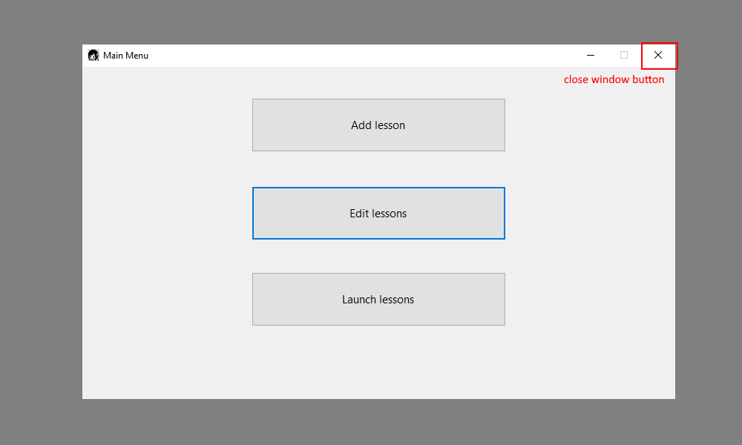

Go to Insert new lesson window

To bring up the Insert new lesson window, click “Add lesson” button in the Main Menu window. In this window you can add a lesson.

Go to Lessons in program window

To bring up Lessons in program window, click “Edit lesson” button in the Main Menu window. In this window you can see lessons and delete a lesson.

Go to edit lesson window

To bring up Edit lesson window, click “Edit item” button in the Lessons in program window. In this window you can edit a lesson.

Go to Links settings window

To bring up Links setting window, click “Edit links” button in the Lessons in program window. In this window you can edit a lesson’s additional link and delete a lesson’s additional link.

Go to launch lessons window

To bring up Links setting window, click “Launch lessons” button in the Main Menu window. In this window you can launch lesson links.

**Features**

Zoomaster role is to help you easily add and append lesson links for your studies. To do so it has the ability to Add Lesson, See Lesson, Delete Lesson, Edit Lesson, Add additional link(s) to Lesson, Delete additional links to Lesson and Launch Lesson.

Input format and warnings

* All input fields have a character limit of 100. If the URL you try to input is more than 100 characters long, use a URL shortener before entering it into the program
* Do not use triple spacing in any input fields. If you have done so, clear your data.txt file.
* Do not delete the data.txt file. If you have accidentally deleted it, create a new text file and name it data.txt.
* You must select an item in the combo box or type an input equivalent to that of an item given in the combo box. Else the program will not recognise it.
* You must give a valid Lesson period i.e. your start time must be before your end time.
* You have to fill all input fields to successfully add/append your lessons.

Add lesson

1. To add a lesson, first navigate to Insert new lesson window.
2. Next, fill in the respective fields.
3. Once done click the “Add new lesson” button.
4. If you have no errors in your input fields, you will hear a ding sound to signify a new lesson was successfully added.
5. Else you will hear an angry buzzer sound.
6. The input fields will be cleared for you to add another lesson.
7. Once done adding lessons, you can click the “Return to main menu” button to return to Main Menu window.

See lessons

1. To see the list of lessons in the program, first navigate to Lessons in program window.
2. You should see your lessons are ordered by day of the week and ascending order of timeslot.
3. You can double click a lesson to select it and see the lesson link and other additional links.
4. To return to Main Menu window, you can click the “Return to main menu” button.

Delete lesson

1. To delete a lesson, first navigate to Lessons in program window.
2. Double click a lesson to select the lesson in your lesson list your wish to remove.
3. Now, click the “Delete item” button and you should see the lesson you selected has been removed from your lesson list.
4. If you click “Delete item” with no selected item, nothing will happen.
5. Once done deleting lessons, you can click the “Return to main menu” button to return to Main Menu window.

How to know if you have selected a lesson

Step 1: No lesson selected initially

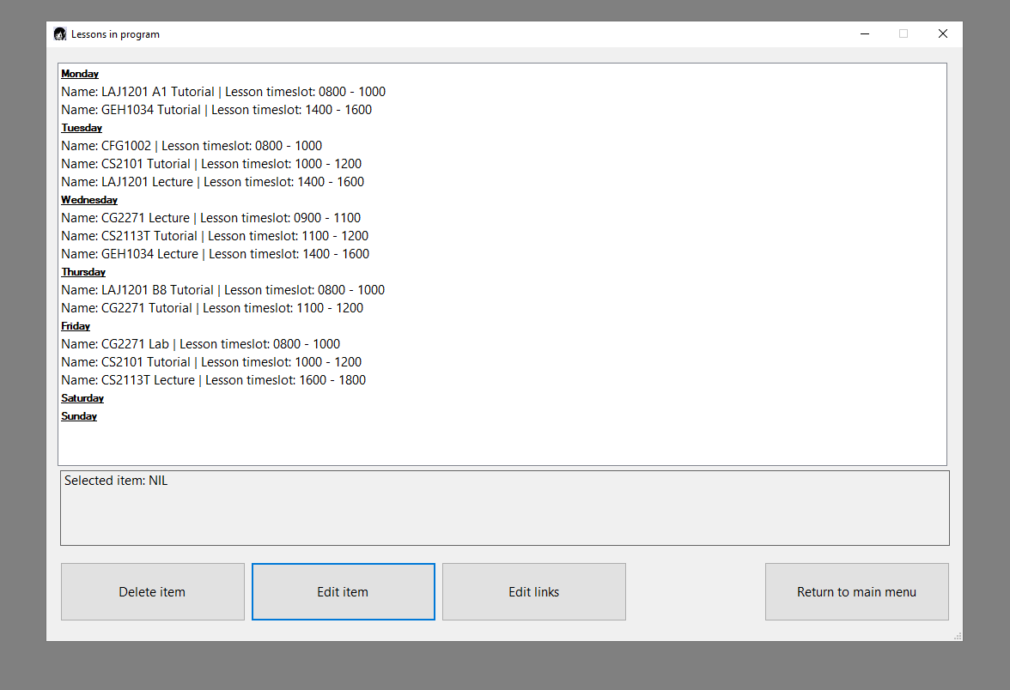

Step 2: Select a lesson. You should see the text box at the bottom of the screen displays the lesson you have selected.

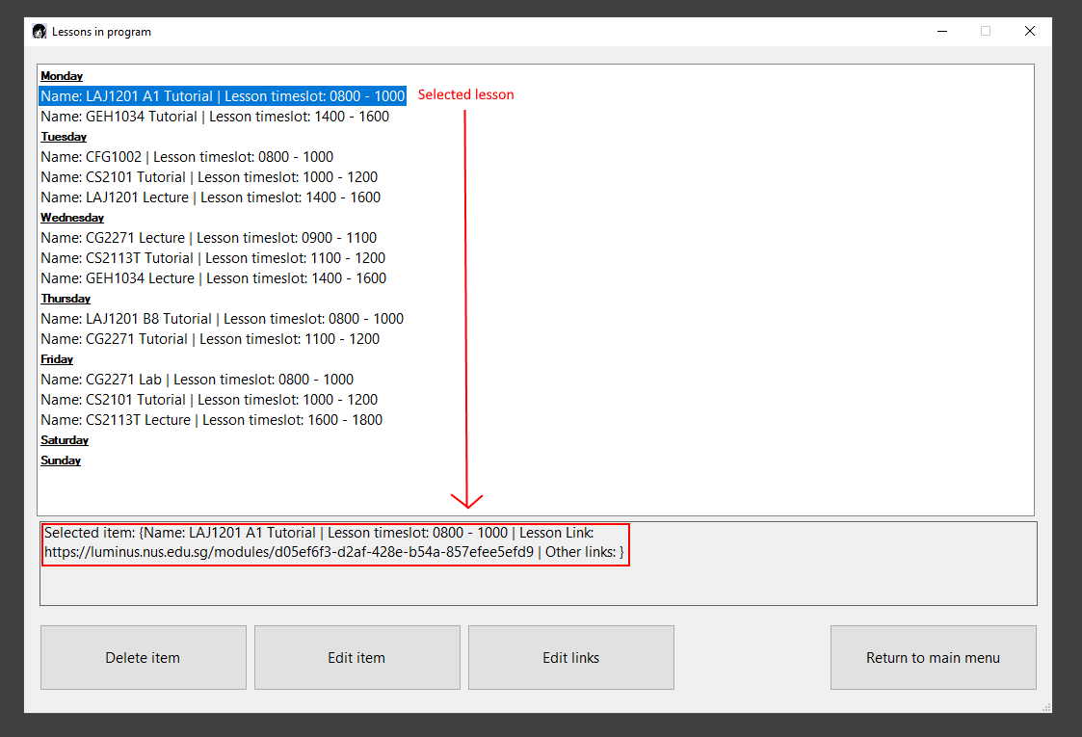

Edit lesson

1. To edit a lesson, first navigate to Edit lesson window.
2. You should see the lesson you have selected and its details in the input fields similar to that of adding a lesson.
3. Now you can make changes the input fields to edit details of the lesson.
4. Note that and edits you make must comply with the input format. If you make changes that do not comply, the program will not register your new changes.
5. Once done or if you clicked the “Go back” button, you will be sent back to the Lessons in program window.

Add additional link

1. To add an additional link to a lesson, first navigate to Links settings window.
2. You should see the name of the lesson you selected is shown in the top most textbox.
3. Next, fill in the Lesson link input field.
4. Once done click the “Add link” button.
5. If you have no errors in your input field, you will hear a ding sound to signify a new lesson was successfully added.
6. Else you will hear an angry buzzer sound.
7. The input fields will be cleared for you to add another link to your lesson.
8. Once done adding lessons, you can click the “Go back” button to return to Lessons in program window.

Delete lesson

1. To delete an additional link of a lesson, first navigate to Links settings window.
2. You should see the name of the lesson you selected is shown in the top most textbox.
3. Next, select the link you wish to remove from your selected lesson in the combo box.
4. Now, click the “Delete link”.
5. If you have no errors in your input field, you will hear a ding sound to signify a lesson link was successfully deleted.
6. Else you will hear an angry buzzer sound.
7. The input field will be cleared for you to delete another lesson link.
8. Once done deleting lessons, you can click the “Return to main menu” button to return to Main Menu window.

Launch lesson

1. To launch a lesson’s links, first navigate to Launch lessons window.
2. You should see two options: Launch lesson now and Launch selected lesson.
3. If you want to launch a lesson that is currently occurring, click the “Launch” button below Launch lesson now option.
4. If there is a lesson currently occurring, it will launch that lesson’s links.
5. Otherwise, nothing happens.
6. If you want to launch a lesson in your list of lessons, select a lesson you wish to launch in the combo box.
7. Then click the “Launch” button below Launch selected lesson option.
8. If you have no errors in your input field, you will hear a ding sound to signify a lesson link was successfully deleted.
9. Else you will hear an angry buzzer sound.
10. The input field will be cleared for you to launch another lesson.
11. Once done deleting lessons, you can click the “Return to main menu” button to return to Main Menu window.

**Glossary**

GUI – Graphical User Interface

**FAQ**